Restricting and Sorting Data
- Display the ENAME, SAL, COMM from EMP table who earn commission and sort the records in descending order of Salary and Commission. Use column's numeric position in the ORDER BY clause.
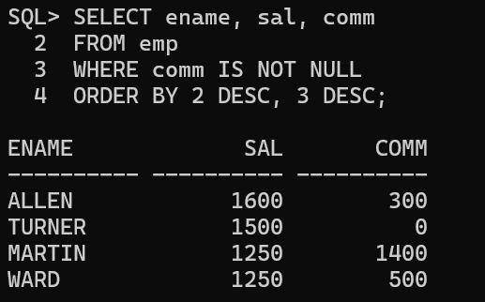

- Display all unique job codes from the EMP table.
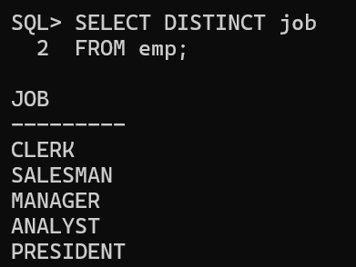

- Display EMPNO, ENAME, JOB, and HIREDATE with column headings Emp #, Employee, Job, and Hire Date.
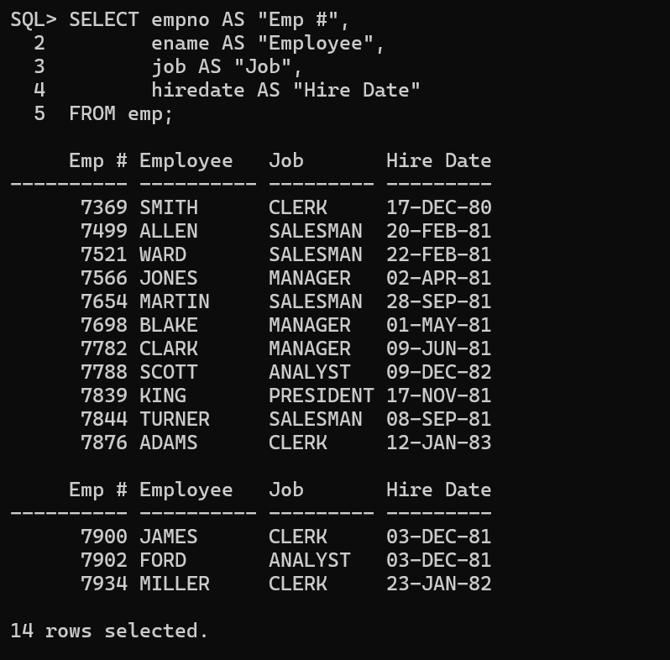

4. Display the employee name concatenated with the job ID (separated by a comma and space). Name the column Employee and Title.

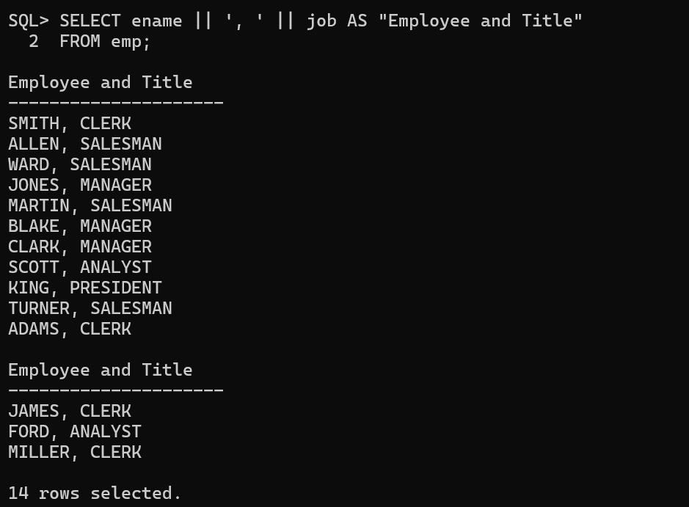

- Display ENAME, JOB, HIREDATE, and MGR separated by commas. Name the column THE_OUTPUT.
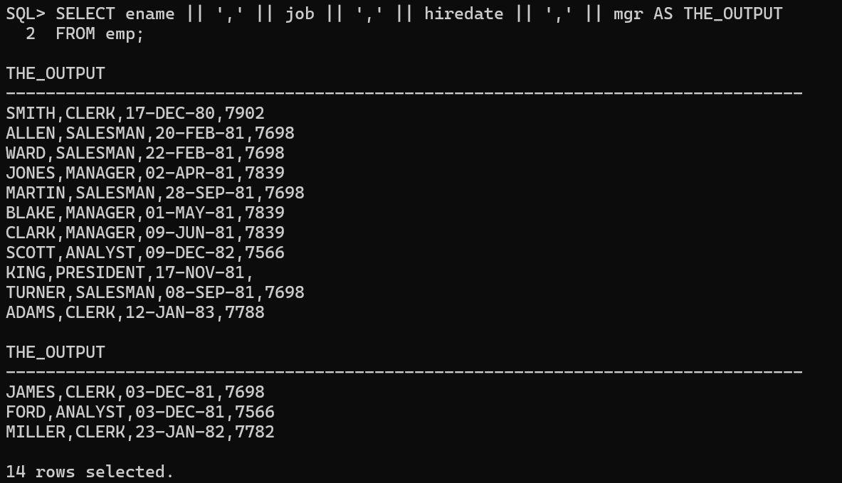

- Display the ENAME, JOB, and HIREDATE for employees named SCOTT or TURNER. Sort by hire date in ascending order.
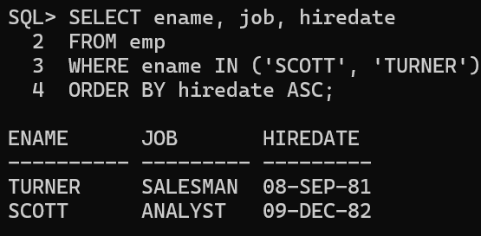

- Display the ENAME and DEPTNO of all employees in departments 20 or 30. Sort alphabetically by employee name.
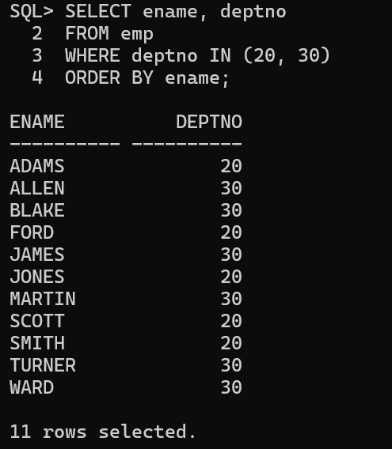

- Display the last name and salary of employees who earn between 2000 and 3000 and are in department 20 or 30. Label the columns Employee and Monthly Salary.
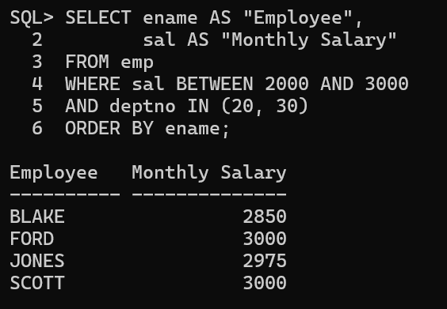

- Display the last name and hire date for all employees hired in 1981.
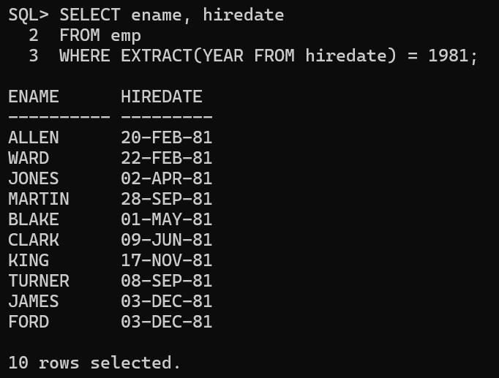

- Display the ENAME and SAL of employees who earn more than the amount entered by the user.
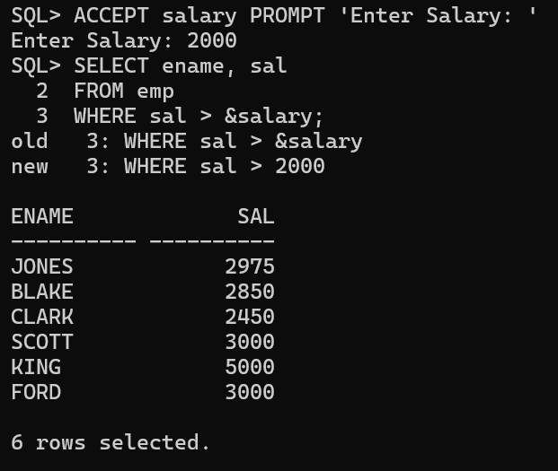

- Display the last name and job title of employees who do not have a manager.
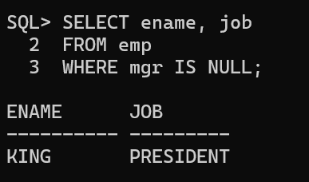

- HR wants a report based on a manager
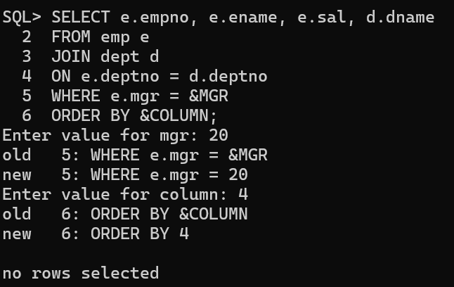

- Display all employee last names in which the third letter is A
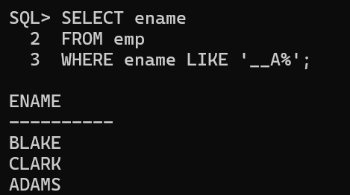

- Display the last name of all employees who have both an A and an S in their ENAME
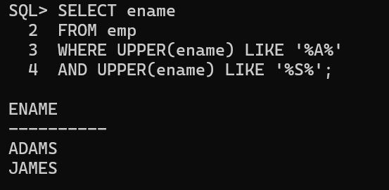

- Display the ENAME, JOB, SAL for all employees whose job is CLERK and whose salary is 800, 950, or 1300
